Inverness Fours and Small Boats Heads 2010
Saturday 6th & Sunday 7th November 2010

Essential Information for Competitors
Firstly can we encourage competitors to arrive early, register early (don't all leave it to the last minute) we can't cope with many crews registering two minutes before they want to boat, and, especially Novice Crews, boat early - Remember there will be time penalties for those crews late to the start.

Trailer and Car Parking
Buses must use the Sports Centre car park, which is clearly signposted.
All cars not carrying small boats must be parked at the Rugby Club car park, coming through Inverness, turn left before crossing the canal. Those cars carrying small boats must park beyond the IRC Boathouse.
Kindly ensure that no cars or trailers are parked in the turning area in front of the IRC boathouse where essential space is required for the PORTALOOS, REGISTRATION CARAVAN and REFRESHMENT MARQUEE

Trailers should be located as follows -

On the towpath to the North of Tomnahurich Swing Bridge (turn right after going over the bridge) – Glasgow UBC/Strathclyde UBC/ St Andrews UBC/George Heriots School

Close to the Jacobite Cruises Office
Aberdeen BC/ ASRA /Aberdeen UBC
NOTE - Three parking spaces must also be left clear on the immediate south side of the Jacobite Cruises office for the use of their staff vehicles

Close to IRC Boathouse (beside tow path before reaching boathouse)
Glasgow RC / St. Andrew BC/Heriot Watt UBC

Beyond IRC Boathouse (beside tow path at turning space before locked gate)
Clyde ARC / Clydesdale ARC / Glasgow Academy/ LLRC/ SPRC and all car topped small boats

Registration - Race entry monies should be paid to H Geddes, 7 Dores Ave, Inverness prior to the weekend. IF PAYING ON THE DAY there will be a 50p /person surcharge.
Bow numbers (Refundable Deposit of £5) and back numbers will be dealt with at registration Caravan. Should Clubs wish to scratch crews, alter crew composition or make other permitted changes, then these will be dealt with at Regatta Control which will be in the control caravan.
PLEASE CARRY OUT THESE TASKS AS SOON AS YOU CAN AFTER ARRIVAL. PLEASE HAVE THE CORRECT ENTRY MONEY IF AT ALL POSSIBLE (IF PAYING ON THE DAY) – THIS WILL HELP SPEED THINGS UP FOR ALL
Boating

Please have respect for your fellow competitors and arrive at the start in time - it can take some crews more than 45 minutes to row to the start. Allocated boating times have been published on the draw – PLEASE CHECK FOR ANY LAST MINUTE CHANGES WHEN REGISTERING

Punctuality:
- All boats must have passed the finishing line on their way to the start no later than 30 minutes before the start time. Late departures will be turned back, in fairness to crews waiting at the start.

- On Saturday, crews must ARRIVE upstream of the start 10 minutes PRIOR to division start time: 11:20 for division 1 start at 11:30 noon, 13:50 for division 2 start at 14:00.

- On Sunday, crews must ARRIVE upstream of the start 10 minutes PRIOR to division start time: 10:50 for division 1 start at 11:00, 13:20 for division 2 start at 13:30.
- Crews must be on their marshalling station or above the start 5 minutes before race start time. A 5 second time penalty will be added for any minute thereafter.

Saturday
First Division - Novice Crews must begin boating at 10:00am Junior Crews at 10:20am, and Senior Crews at 10:30am. Remember to take sufficient warm and weatherproof clothing with you.
Second Division - Novice Crews must begin boating at 12:45pm, Junior Crews at 1:00pm, and Senior Crews at 1:10pm. Remember to take sufficient warm and weatherproof clothing with you.

Sunday
First Division - Novice Crews must begin boating at 9.30am Junior Crews at 9:50am, and Senior Crews at 10:00am. Remember to take sufficient warm and weatherproof clothing with you.
Second Division - Novice Crews must begin boating at 12:15pm, Junior Crews at 12:30pm, and Senior Crews at 12:40pm. Remember to take sufficient warm and weatherproof clothing with you.

Wishing you all a successful weekend (and no time penalties )
Regatta Organising Committee, Inverness Rowing Club – November 2010

See also details below relating to Showering at Inverness Sports Centre and Saturday night function
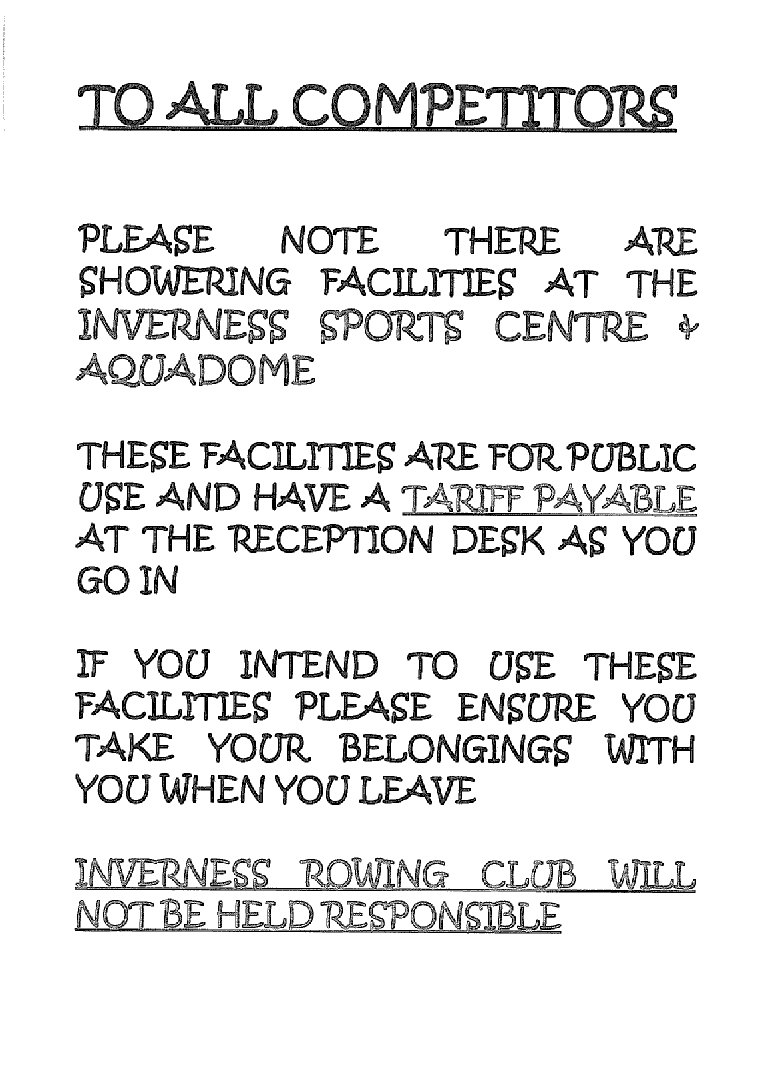

Come & Join Us at The Castle Tavern, Saturday Evening

6th November 2010

all Welcome, families, supporters … Numbers are Limited to 40 so first come first served

please contact HAZEL SMITH
at hazel.smith2@nhs.net to book your place

Excellent value at only £16 per head for 3 courses!

